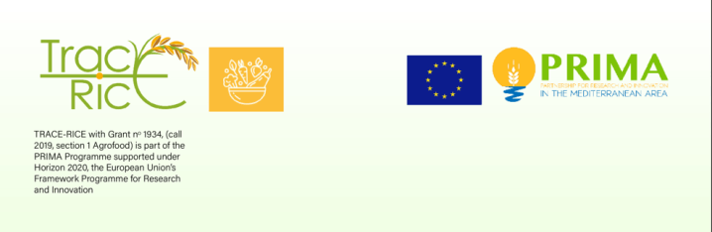

# Note: General Font type: Times New Roman

Format A4 (1 pag. maximum); Left margin 3 cm, other margins 2.5 cm each. Start the first page with [2 lines free, 12 pt]

**How to prepare a ready for print abstract for the IOBC-WPRS bulletins** [font: 14 pt, bold, flush left]

# [1 line free, 12 pt]

**Horst Bathon1, Luc Tirry2**[font 12 pt, bold]

*1BBA, Institute for Biological Control, Heinrichstr. 243, D-64287 Darmstadt, Germany;*

*2University of Gent, Department of Crop Protection, Laboratory of Agrozoology, Coupure Links 653, B-9000 Gent, Belgium* [font: 11 pt, italics, block]

# corresponding e-mail address: [font: 11 pt, italics, block] [2 lines free, 12 pt]

**Abstract**[font: 12 pt, bold]: Twenty years ago, IOBC published a document that can be considered as one of the cornerstones of Integrated Production in Europe. Key element in this collection of documents is the Declaration of Ovrannaz. It was established by a group of entomologists that met in the Switzerland to discuss basic aspects and principles of Integrated Plant protection and production. It is gratifying to observe that the work of the IOBC carried out during the last 20 years has not only found its precipitation in European agriculture but has also generated interest outside the WPRS-region. [font: 12 pt]

# [1 line free, 12 pt]

**Key words** [font: 12 pt, bold]: pests, diseases, integrated control [font: 12 pt]

# [2 lines free, 12 pt]

**Acknowledgements** [font: 12 pt, bold, flush left] [1 line free, 12 pt]