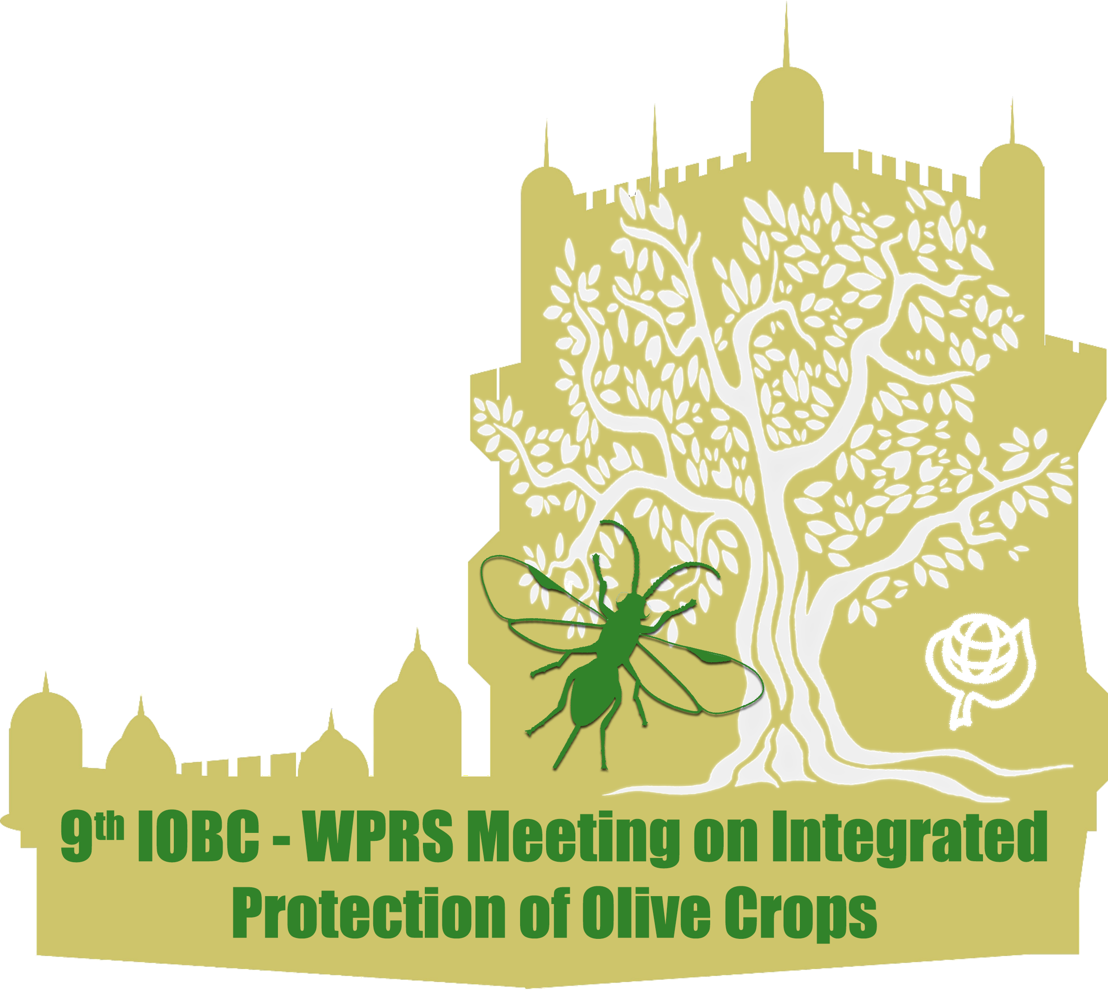

Note: General Font type: Times New Roman

Format A4; Upper margin 3 cm, other margins 2.5 cm each.

Start the first page with [2 lines free, 12 pt]

**How to prepare a ready for print manuscript for the IOBC-WPRS bulletins** [font: 15 pt, bold, flush left]

[1 line free, 12 pt]

**Horst Bathon1, Luc Tirry2**[font 12 pt, bold]

*1BBA, Institute for Biological Control, Heinrichstr. 243, D-64287 Darmstadt, Germany; 2University of Gent, Department of Crop Protection, Laboratory of Agrozoology, Coupure Links 653, B-9000 Gent, Belgium* [font: 12 pt, italics, block]

e-mail address(es) (if desired): [font: 12 pt, italics, block]

[2 lines free, 12 pt]

**Abstract**[font: 11 pt, bold]: Twenty years ago, IOBC published a document that can be considered as one of the cornerstones of Integrated Production in Europe. Key element in this collection of documents is the Declaration of Ovrannaz. It was established by a group of entomologists that met in the Switzerland to discuss basic aspects and principles of Integrated Plant protection and production. It is gratifying to observe that the work of the IOBC carried out during the last 20 years has not only found its precipitation in European agriculture but has also generated interest outside the WPRS-region. [font: 11 pt]

[1 line free, 11 pt]

**Key words** [font: 11 pt, bold]: pests, diseases, integrated control [font: 11 pt]

[2 lines free, 12 pt]

**Introduction** [font: 13 pt, bold, flush left]

[1 line free, 12 pt]

Twenty years ago, IOBC published a document that can be considered as one of the cornerstones of Integrated Production in Europe (Gessler, 1989). Key element in this collection of documents is the Declaration of Ovrannaz. It was established by a group of entomologists that met in the Switzerland to discuss basic aspects and principles of Integrated Plant protection and production (Crumble & Notsch, 1999). It is gratifying to observe that the work of the IOBC has also generated interest outside the IOBC-WPRS –region (Sigsgaard *et al*., 2011). [font: 12 pt, no indent]

It is gratifying to observe that the work of the IOBC carried out during the last 20 years has not only found its precipitation in European agriculture but has also generated interest outside the IOBC-WPRS -region. [font: 12 pt, indent of first line: 0.8 mm]

[2 lines free, 12 pt]

**Material and methods** [font: 13 pt, bold, flush left]

[1 line free, 12 pt]

***Insect rearing*** [font: 12 pt, bold, italics, flush left]

Twenty years ago, IOBC published a document that can be considered as one of the cornerstones of Integrated Production in Europe. Key element in this collection of documents is the Declaration of Ovrannaz. It was established by a group of entomologists that met in the Switzerland to discuss the principles of Integrated Plant protection. [font: 12 pt]

[1 line free, 12 pt]

***Fungicides***[font: 12 pt, bold, italics, flush left]

Twenty years ago, IOBC published a document that can be considered as one of the cornerstones of I. P. in Europe. Key element in this collection of documents is the Declaration of Ovrannaz. It was established by a group of entomologists. [font: 12 pt]

[2 lines free, 12 pt]

**Results and discussion** [font: 13 pt, bold, flush left]

[1 line free, 12 pt]

***Please avoid typing errors*** [font: 12 pt, bold, italic, flush left]

Twenty years ago, IOBC published a document that can be considered as one of the cornerstones of Integrated Production in Europe. Key element in this collection of documents is the Declaration of Ovrannaz. It was established by a group of entomologists that met in the Switzerland to discuss the principles of Integrated Plant protection [font: 12 pt, block]

[2 lines free, 12 pt]

**! Figures should be centred !**

[1 line free, 12 pt]

Figure 1. Development of insect eggs under different temperatures (°C). [font: 12 pt]

[2 lines free, 12 pt]

***How to refer to figures and tables*** [font: 12 pt, bold, italic, flush left]

Please refer to Figures and Tables in the text by using no abbreviations and by using capital first letter: In Figure 1 development of insect eggs under different temperatures is shown.

An overview of insect species with preferences for higher temperatures is given in Table 1. [font: 12 pt, indent of first line: 0.8 mm]

[1 line free, 12 pt]

***Field trial results*** [font: 12 pt, bold, italic, flush left]

Twenty years ago, IOBC published a document that can be considered as one of the cornerstones of Integrated Production in Europe.

Key element in this collection of documents is the Declaration of Ovrannaz. It was established by a group of entomologists. [font: 12 pt, indent of first line: 0.8 mm]

[2 lines free, 12 pt]

Table 1. Do not forget to centre the tables. This way the lay-out will improve and the bulletin will look a lot nicer. [font: 12 pt]

[1 line free, 12 pt]

|  |  |  |  |  |
| --- | --- | --- | --- | --- |
|  | **Tables should be centred!!!** | |  |  |
|  |  |  |  |  |
|  |  |  |  |  |

[2 lines free, 12 pt]

**Acknowledgements** [font: 13 pt, bold, flush left]

[1 line free, 12 pt]

We thank you for following these guidelines carefully. [font: 12 pt]

[2 lines free, 12 pt]

**References** [font: 13 pt, bold, flush left]

[1 line free, 12 pt]

Beckleheimer, J. 1994: How do you cite URLs in a bibliography? [WWW document] URL [http://www.nrlssc.navy.mil/meta/bibliography.html. Cited 20 Apr. 2012](http://www.nrlssc.navy.mil/meta/bibliography.html.%20Cited%2020%20Apr.%202012). [font: 12 pt, indent second and following lines: 0.8 cm]

Crumble, R. D. & Notsch, B. G. 1999: Variation in host range, systemic infection and epidemiology of *Leptosphaeria maculans*. Plant Pathol. 43: 269-277.

Erwin, D. C. & Ribeiro, O. K. 1996: Phytophthora Diseases Worldwide. APS Press, St. Paul, USA.

Gessler, C. 1989: Genetics of the interaction *Venturia inaequalis – Malus*: the conflict between theory and reality. In: Integrated Control of Pome fruit Diseases, Vol. II, eds. Gessler, Butt and Koller: 168-190.

Pérez, J., Rojas, J. C., Montoya, P., Liedo, P., González, F .J. & Castillo, A. 2012: Size, shape and hue modulate attraction and landing responses of the braconid parasitoid *Fopius arisanus* to fruit odour-baited visual targets. BioControl doi:[10.1007/s10526-011-9416-0](http://dx.doi.org/10.1007/s10526-011-9416-0)

Sigsgaard, L., Vogt, H. & Weintraub, P. G. 2011: Voices from vice-presidents of the IOBC-WPRS. IOBC-WPRS Bull. 57: 123-456. [note: before Volume 30, 2007, the issue number must be included, e.g. 30(1): 12-15.]

Note: The doi is reserved for journals that appear only online.